Capstone Project

Forecasting the Commute: Modelling Weather Effects on Wellington Traffic

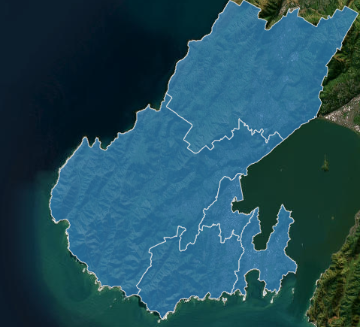
Fig 1. WCC voting wards/traffic count site aggregated “zones”

Rachel Anastasi-Marais
07/11/2025

Table of Contents
Problem statement 3
Industry/ domain 4
Stakeholders 5
Business question 5
Data question 6
Data 6
Data science process 8
Data analysis 8
Exploratory Data Analysis (visualisations) 11
Modelling 15
Outcomes 20
Implementation 21
Data answer 21
Business answer 21
Response to stakeholders 21
End-to-end solution 21
References 22

Problem statement
The weather in Wellington, New Zealand — especially its notorious wind — elicits a variety of responses from residents and visitors, from running for cover, to securing loose objects against damage. Among these responses, road users show an observable pattern: when the weather turns bad, they get behind the wheel.
Conversely the popular idiom, “you can’t beat Wellington on a good day”, is reflected in increased travel to and around Wellington when the weather is fine, as residents and visitors take the opportunity to explore the city and its surrounding landscape.
While it is well established that weather influences traffic volumes, the focus of this analysis is to understand how weather affects commuter traffic in Wellington. Specifically, we investigated whether particular combinations of weather metrics (such as rain, wind, and temperature) are associated with changes in vehicle counts, and whether these effects are moderated by contextual factors such as time of day or season.
Predicting weather and contextual factors that influence traffic counts has implications for the decisions of many Wellingtonians, from City Council road maintenance schedules, public transport service providers and their users, to manufacturers of outdoor clothing seeking novel way to advertise specific weather gear. Anticipating higher traffic volumes can also help individual road users: they may alter travel habits to avoid congestion, take advantage of improved traffic flow, or enjoy a safer commute on the city’s new cycle lanes.

Severe weather can be widely disruptive around the Wellington region; heavy rain can trigger slips and flooding, necessitating road closures; high winds can result in flight cancellations, and storm surges disrupt ferry sailings and coastal train services.
The New Zealand Transport Authority (NZTA) recommends motorists “drive to the conditions”, often lowering posted speeds on electronic signs in response to high winds and heavy rain [1]. In late February 2024, users on the r/Wellington subreddit debated the causes of traffic congestion during bad weather. One commenter suggested that a pool of workers who usually cycle or take public transport switch to driving when it rains. As they are less practiced drivers, they tend to be slower and more cautious than daily commuters [2].
There may be some truth to this: in 2018, around 24% of Wellingtonians reported walking or cycling as their main mode of commuting [3]. If even a portion of these commuters chose to drive on wet days, the result would be a substantial increase in traffic volumes.
The Greater Wellington Regional Council (GWRC) has examined the effects of traffic accidents, natural hazards, and the growing impact of climate change on Wellington’s transport network [3]. However, we could find no recent studies that consider the broader influence of day-to-day weather on commuter traffic.

Industry/ domain
This project sits at the crossroads of transport planning, urban mobility, and data science, with a focus on how weather and contextual factors shape commuter traffic in Wellington. The city’s transport network already faces well-known pressures: peak-hour congestion, exposure to severe weather, and the growing need to adapt to climate changes. While the GWRC and the NZTA have investigated the effects of accidents, natural hazards, and long-term climate risks, there has been little recent attention paid to the everyday influence of weather on commuter traffic volumes. At the same time, several wider trends are reshaping the industry: from an increased focus on sustainable transport and the implementation of more cycling infrastructure, to the growing reliance on real-time data in traffic management.
The value chain in this space is wide-ranging with multiple stakeholders. Weather services and automatic traffic measurement systems feed into the system as essential inputs. Transport authorities such as the NZTA, the GWRC, and the Wellington City Council (WCC) plan and manage the infrastructure. Public transport operators and road maintenance contractors deliver services that keep the network moving. Daily commuters, businesses, and logistics companies are the end users, while secondary stakeholders — advertisers, and emergency services — also benefit from insights into how traffic responds to weather.
Several key concepts underpin this analysis: the dynamics of traffic flow and congestion; the ways rain, wind, flooding, slips, and storm surges affect mobility; the choices commuters make between private vehicles, public transport, cycling, and walking; the resilience of the system in the face of hazards and climate change; and the growing reliance on predictive modelling and real-time monitoring to guide transport decisions.
Although the focus here is Wellington, the methods and insights extend well beyond the city. They have relevance for public transport planning, where service levels can be adjusted to meet demand; for logistics and freight, where anticipating weather-related delays is critical; for retailers and advertisers tailoring campaigns to weather-sensitive products; and for urban resilience and emergency planning, where better forecasts can inform infrastructure investment and disaster response.

Stakeholders
Being collectively responsible for roads in and around Wellington, the GWRC and WCC are the primary stakeholders for this project. Their use of data driven insights will have a direct impact on road users, influencing road access, repair, detours, and the implementation of various transport and weather infrastructure, including bus shelters [4]. Traffic count data collected by the Wellington City Council has several uses, which include “helping road workers decide the best times to work on the road to cause the least disruption, as an input for [their] traffic engineers to implement effective road safety initiatives, and for [their] road maintenance team to forecast maintenance and prioritise annual work programmes”[5].

Business question

Both the GWRC and the WCC may benefit from data insights relating to infrastructure and climate change resilience. Freight and logistics companies may use insights to manage delivery timeline expectations. Public transport agencies, already using real-time service arrival updates, may opt to increase fleet deployment proactively, when they know the weather will change. Outdoor apparel brands may seek to explore an otherwise weather-averse customer base, normalising commuting in any reasonable weather. Individual motorists are often motivated by time, and may be highly motivated by additional insights to aid in drive-time planning.
Having insight into the impact of both good and bad weather on traffic enables better business and personal planning, customer communication, and constituent confidence in civic leaders. It presents advertising opportunities that may benefit commercial companies, while reducing Wellington’s carbon footprint, and encouraging health and fitness.

Data question

The data question for this Project is “How do select weather and contextual traffic features contribute to predictive models of commuter traffic volumes in Wellington?” To answer this question we needed data that measured traffic counts while considering count site location, time of year, and time of day; and weather data for the target areas of Wellington. We needed both datasets to be for an equivalent period and at an equivalent granularity.

Data

This project uses data from two sources, both publicly available at no cost.
Traffic data was downloaded from the Wellington Transport Analytics website in an Excel file, “WCC_2024.xlsx” (i.e. Wellington City Council, 2024) [6]. This document includes two datasheets applicable to this project:
  - [WCC_sites_2024]: containing traffic count site locations expressed as Eastings and Northings, and
  - [WCC_tube_count_2024]: traffic count data by site, date, and directionality, at 15-minute intervals.
This data covers the period 16/02/2024 to 22/11/2024. The data is complete, with no missing values per observation.
Comparing observations per month relative to the full dataset, March has the highest percentage of observations (22.7%) while June has the lowest (5.4%). Grouping months into seasons, autumn has the highest percentage of observations (37.6%), while summer has the lowest (6.2%). The first and last months, February, and November, respectively, are incomplete. We checked the 2023 dataset to understand data inconsistencies for 2024 data, and found similar patterns.

Traffic counts were collected using Automatic Traffic Counters (ATC), which are a pair of black tubes fastened to the road [5]. According to the Lead Modeller at Wellington Transport Analytics, tube data collection can be disrupted when the tubes detach from the road. This can be due to either installation error or traffic agitation. Sun-softened asphalt could also make this more likely in the warmer months.
Wellington Transport Analytics also advised that they explicitly sought to include days/weeks that represent typical traffic for most of the year. This means public and school holidays were explicitly omitted, and traffic counts were started in February after a major public holiday (Waitangi Day on 6th of February) had passed.

TABLE I
MONTHLY TRAFFIC DATASET COVERAGE AND SEASONAL DISTRIBUTION
Month | Dates |  |  | Sites / Month | Row count |  | Season | % per Season
Month | # per Month | # Traffic Measured | # Holidays | min → max | per month | % of total | Season | % per Season
Feb | 29 | 13 | 0 | 2 → 15 | 20,160 | 6.2 | Summer | 6.2
Mar | 31 | 17 | 1 | 5 → 35 | 73,920 | 22.73 | Autumn | 37.6
Apr | 30 | 9 | 12 | 5 → 18 | 24,192 | 7.44 | Autumn | 37.6
May | 31 | 21 | 0 | 1 → 10 | 24,192 | 7.44 | Autumn | 37.6
Jun | 30 | 21 | 2 | 3 → 6 | 17,472 | 5.37 | Winter | 27.7
Jul | 31 | 10 | 10 | 6 → 16 | 20,544 | 6.32 | Winter | 27.7
Aug | 31 | 29 | 0 | 1 → 20 | 52,032 | 16 | Winter | 27.7
Sep | 30 | 16 | 2 | 1 → 3 | 22,848 | 7.02 | Spring | 28.5
Oct | 31 | 16 | 9 | 1 → 29 | 46,848 | 14.4 | Spring | 28.5
Nov | 30 | 12 | 0 | 1 → 17 | 23,040 | 7.08 | Spring | 28.5
Totals | 304 | 164 | 36 |  | 325,248 | 100% |  | 100%
Average | 30.4 | 16.4 | 3.6 | 3 → 17 | 32,525
Note: 2024 was a leap year.

Table I reflects reduced traffic count dates in months with heavy public or school holidays: There are 12 public/school term break holidays during April, and 10 in July, heavily influencing available traffic count data for those months. In contrast, June has only two weekday public/school holidays, but also has the lowest row count percentage of the measured months. This suggests that holidays are not the only factor influencing count data.
Note: not all sites used the same measurement dates.

As shown in Table I, the initial row count for traffic data was 325,248 rows.

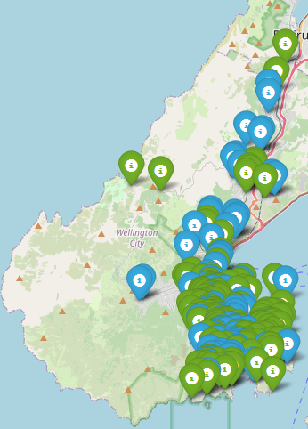
Traffic count sites were sections of various roads around the Wellington region, ranging between Tawa (north), Makara (west), Owhiro Bay (south), and Seatoun (east). Count sites were either a section of road between two side streets or a side street between two main streets.
Traffic measurement sites were
grouped by the length of each measured road section and labelled differently:
Sites with a “site_id_global” label appear to measure travel over shorter sections of road. Sites with no site_id_global appear to measure travel over longer sections of road. We differentiated between these to enable plotting each set separately on one Folium map, to better visualise the distribution of both sets together. Site types were not differentiated for Exploratory Data Analysis (EDA) or Modelling. Fig. 2. Traffic sites coloured by site_id_global (blue) or not (green)

We called the open-meteo.com API to access historical weather data.
This data is based on reanalysis datasets and uses a combination of weather station, aircraft, buoy, radar, and satellite observations [7].
The weather dataset comprised temperature (°C), wind speed and gusts at 10m above sea-level (Km/h), rainfall (mm), and sunshine (seconds, encoded as minutes). The dataset also included weather code, giving us a standardised measure of weather intensity [8]. The full weather data set was initially 43,920 rows, with no missing values.

Data science process

Data analysis
We manually processed traffic data to remove the majority of weekend dates and hours outside the target commuter periods. In future, this step could easily be done programmatically.
We loaded traffic data into two Spark dataframes, one for each of the two Excel sheets we were interested in. The first dataframe included site data, with site IDs, and location data. The second dataframe included corresponding site IDs, along with count, date, and directionality in 15-minute intervals.
We considered a comparison between holiday vs non-holiday traffic [9]. However, since only one holiday date was included in the traffic dataset we opted not to include public holiday labels.
The target variable is traffic counts per hour for two commuting periods, 6:00am-9:00am (“AM” label) and 4:00pm-7:00pm (“PM” label) on weekdays. We aggregated quarter-hourly traffic counts into hourly counts then labelled the first, second, and third hour of each commuting period with “1”, “2”, and “3”, respectively. This gives us more opportunity to differentiate between the effects of positional commuting hours on traffic counts.
Count data included directional flags relating to traffic movement, Southbound/Northbound or Eastbound/Westbound. We applied “in” and “out” labels for traffic directionality relative to the approach of each site to or from central Wellington. For example, if a vehicle travelling over measurement site 1, Northbound, would have been oriented toward central Wellington, we labelled that row, “in”, and the Southbound row, “out”. This approach resulted in a pattern where measurement sites south of the city would typically have northbound directionality labelled, “in”. Sites north of the city would typically have southbound directionality labelled “in”. We applied the same relative pattern to sites located to the east and west of central Wellington. Where there were exceptions based on the orientation of the site, we selected the directionality that would place a vehicle closest to a main road.
We included one-way streets with two-way bike lanes, but excluded six traffic measurement sites on one-way streets with zero (legal) traffic contraflow.
We used the WCC voting ward boundaries (see Fig. 3) as a guide to define different “zones” for traffic origin/destination. Zones were labelled, North, South, East, West, and Central.
Site Eastings and Northings were converted into latitude and longitude, and representative centroid coordinates determined for each zone.
Using these representative coordinates, we accessed historical weather data from open-meteo.com via five separate API calls (one call per zone). Weather data was collected into a single Spark DataFrame.

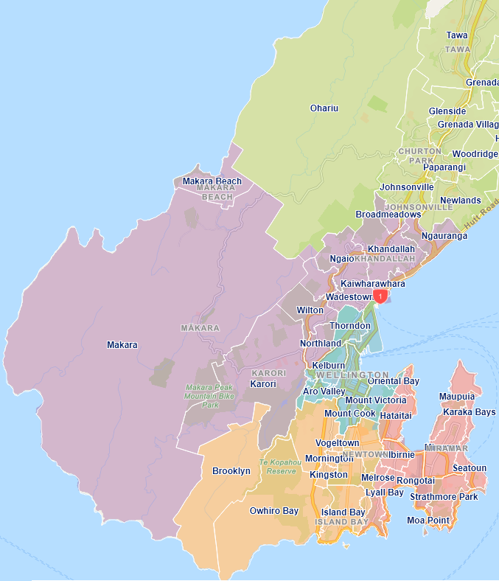
Fig. 3. Wellington City Council voting wards [10]

The traffic and weather dataframes are joined on date and hour.
We applied weather features for the previous hour to each of our target commuter hours. This enables us to use weather data to predict traffic counts in the subsequent hour.

After data cleaning, the resulting combined row count for traffic data and weather data is 14,160 rows.

Exploratory Data Analysis (visualisations)

This Pearson correlation coefficient matrix of traffic count, contextual traffic features, and weather features (Fig. 4) shows a very strong relationship (0.99) between wind speed and gusts. While the maximum sustained wind speed for this dataset was 58.7 Km/h, maximum gusts reached 106.6 Km/h, (see Table II). Given gusts represent a short-term impact relative to sustained wind speed, we opted to keep both features as predictors. Also note, the relationship between temperature and wind related features which may suggest underlying meteorological interactions worth further exploration.
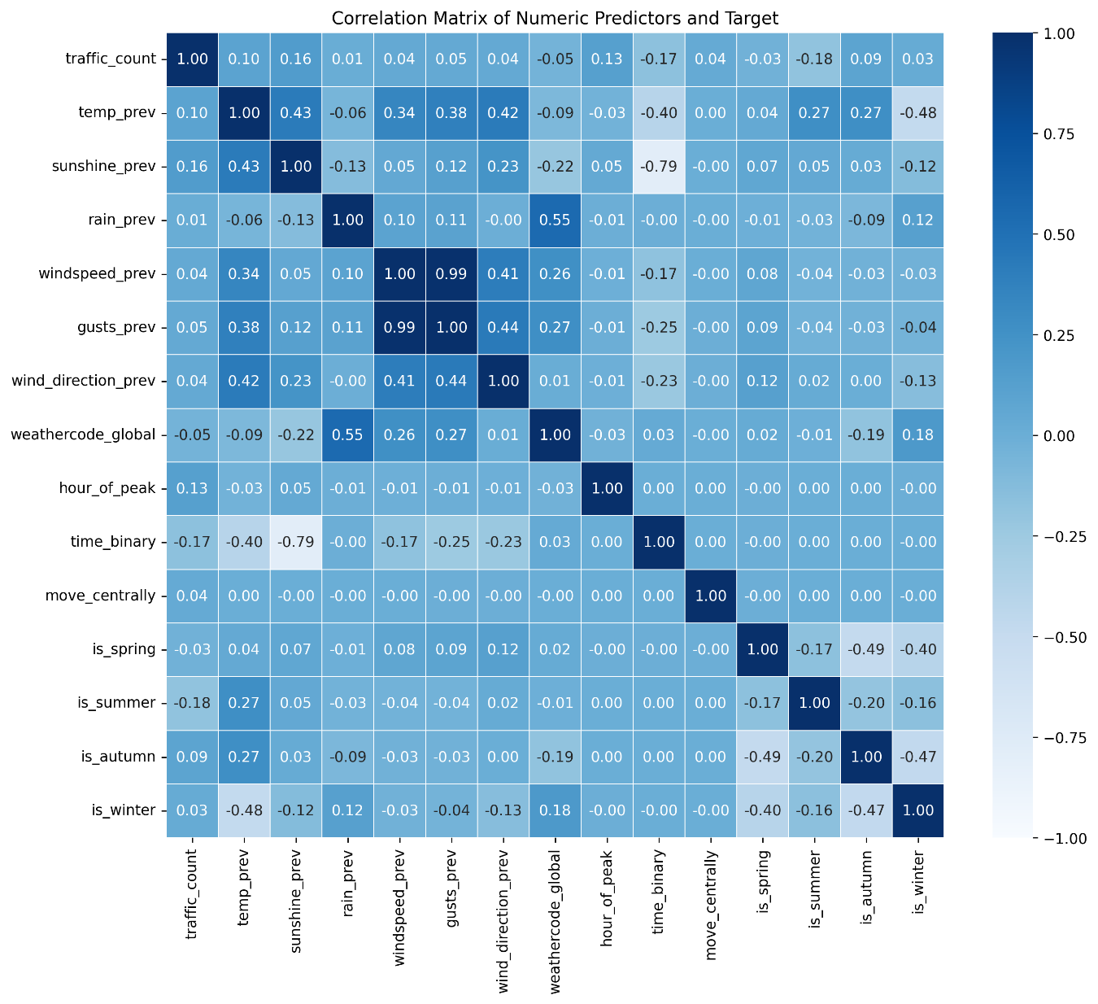
Fig. 4. Pearson correlation: traffic counts vs initial predictor features

TABLE II
COMPARISON OF MAXIMUM AND MINIMUM WIND SPEED AND WIND GUST VALUES
Wind speed |  |  | Gusts
Min | Max | Mean | Min | Max | Mean
1.1 | 58.7 | 23.88 | 3.2 | 106.6 | 49.53
Wind speed mode: Row (wind speed =20.3, count=140)
Gusts mode: Row (gusts =48.6, count=180)

We found a moderate relationship of 0.55 between “weathercode_global” (scaled weather intensity), and rainfall (Fig. 4). This indicates that higher rainfall is associated with higher weather intensity codes.

We further explored the relationship between wind direction and rainfall in
Fig. 5 (below), a bar plot with error bars representing variance. This plot suggests that rainfall in the previous hour may increase driving activity; however, this effect is significantly modified by wind direction: Average traffic counts are higher under moderate rainfall when the wind direction is generally from the south, with relatively low variance in these pairings.
Notably, when a direct southerly wind paired with dense drizzle, the traffic count did not increase substantially, but the error bar is the largest measured on this plot (very high variance in traffic counts). This could possibly be explained by further exploring the relationship between these features and temperature.
In contrast there are also relatively high traffic counts when pairing westerly wind with either slight rainfall (low variance) or mainly clear conditions (high variance). This indicates that that there are other factors influencing the increased traffic count in those hours.
The National Institute of Water and Atmospheric Research (NIWA), describes westerly winds over Wellington as being driven by anticyclones (warmer winds) north of the region. Furthermore, Cook Strait (located in the Roaring Forties), separates the mountainous North and South Islands, acting as a “giant wind tunnel”, funnelling these winds into Wellington [11]. Higher traffic counts in hours with westerly winds could be explained further by considering the wind speed or gusts in those hours.
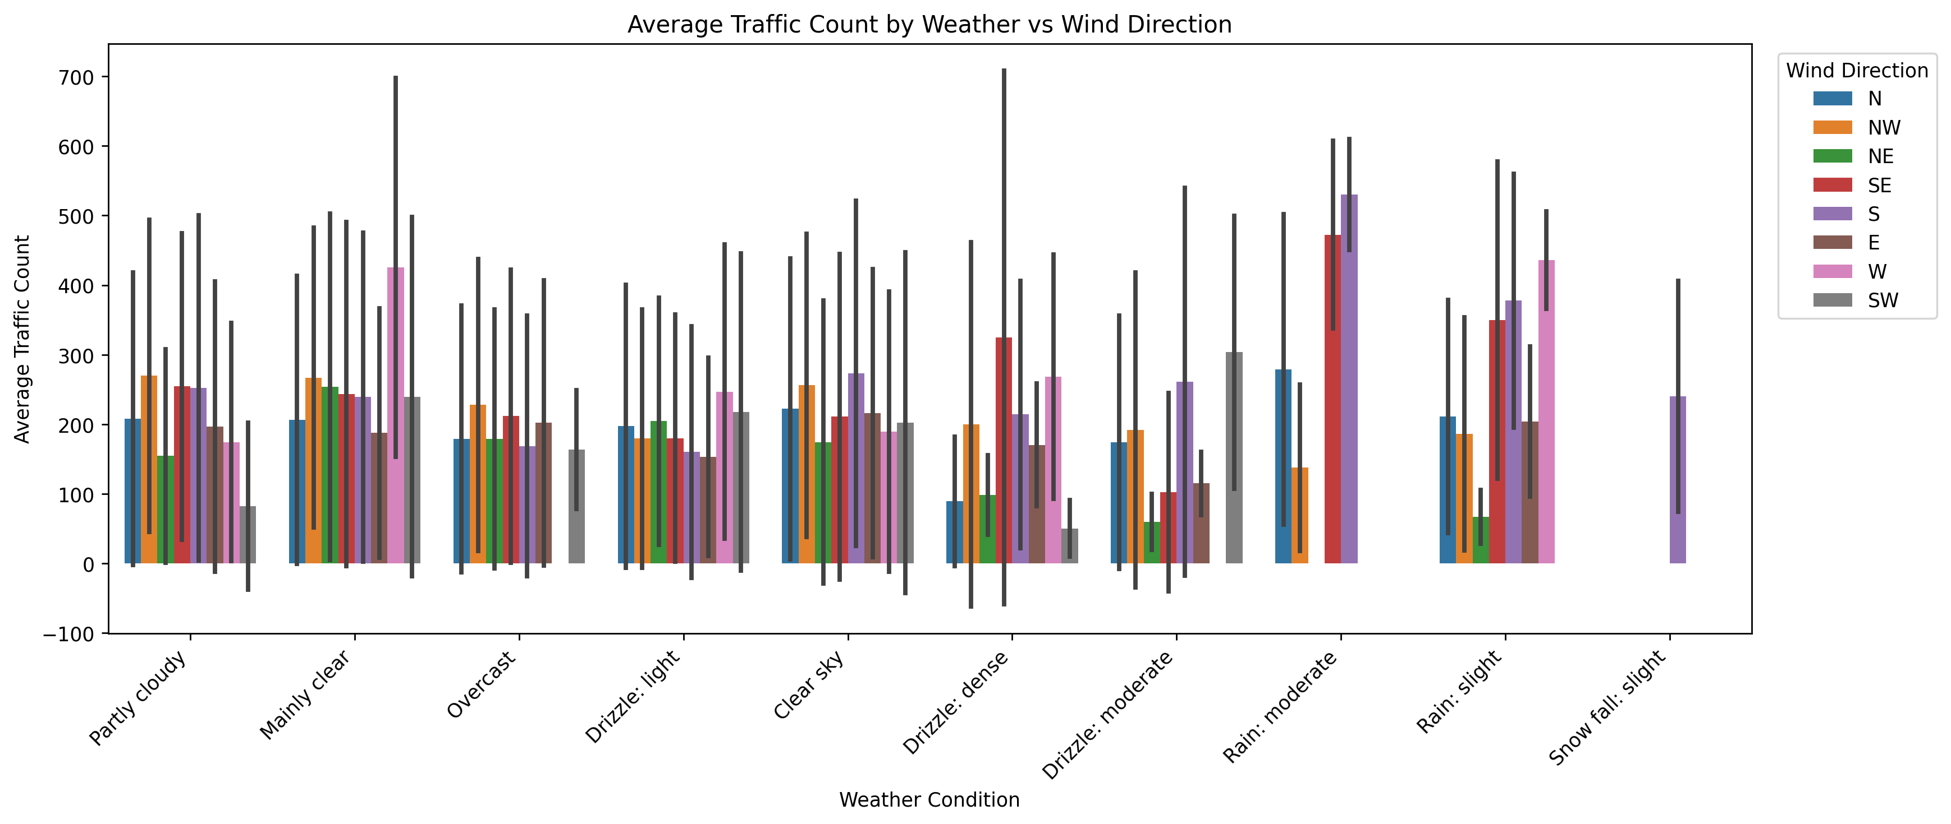
Fig. 5. Average traffic counts by scaled weather intensity code and wind direction

A notable inconsistency arises with traffic counts recorded against days with, “Snow fall: slight”. Wellington rarely experiences snow. There was a very minor snow fall in 2022, a significant snow fall in 2011, and prior to that no snow since 1976 [12]. This snowfall weather code could be an artefact of the combined weather sources making up the historical data set at open-meteo.com.

During the morning (AM) period, traffic counts rise steadily from ~75 vehicles in Hour 1 to ~250 vehicles in Hour 3, while evening (PM) traffic peaks in Hour 2 at >250 vehicles (Fig. 6, below). Hour 1 of the evening period is comparable to Hour 3 of the morning commute. Overall, the PM commuter period shows higher average traffic counts.
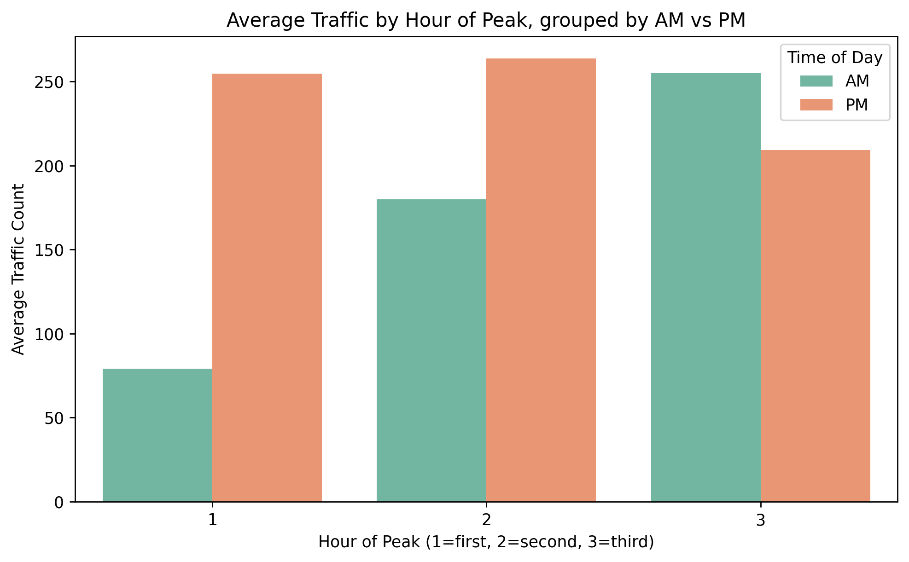
Fig. 6. Average traffic by positional hour within each commuting period

In Fig. 7 (below), we can see that autumn (red plot points) is more consistently represented across zones in comparison to the other seasons. Looking at the zone closer to central Wellington, winter (blue) has higher average traffic counts across zones.
Relative to spring (green) traffic counts in the other zones, the high count in the north zone is surprising. Notably, despite scarce data for the summer months, all zones excluding the west zone appear to have a summer traffic count (yellow).

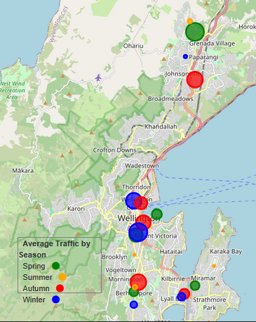
Fig. 7. Average traffic counts per zone with season markers sized by traffic count

Modelling

We grouped predictors by feature type and created a separate zone_feature list, to enable a normalising step in the pipeline for (categorical) zone data prior to OneHot encoding.
Seasonal variables were defined during EDA: We added three of the four seasons to the list of predictors, and dropped “is_autumn” as a reference variable, consistent with the OneHot treatment for other binary variables.

The modelling pipeline used a ColumnTransformer pre-processor to scale numeric features; OneHot encode cateogorical features, and perform normalisation and OneHot encoding for the zone feature. Binary and seasonal indicators were passed through, unchanged, to maintain their current encoding.
TABLE III
SELECTED FEATURES WITH TYPE, TREATMENT, AND INCLUDED/REFERENCE VARIABLES
Feature | Type | Treatment | Included Variables | Reference
season | B | Passed through | is_spring | is_autumn
season | B | Passed through | is_summer | is_autumn
season | B | Passed through | is_winter | is_autumn
zones | B | OneHot encoded | zone_east | zone_central
zones | B | OneHot encoded | zone_north | zone_central
zones | B | OneHot encoded | zone_south | zone_central
zones | B | OneHot encoded | zone_west | zone_central
time_binary | B | Passed through | AM = 1, PM = 0 | None
move_centrally | B | Passed through | in = 1, out = 0 | None
hour_of_peak | C | OneHot encoded | (2) = 6-8am or 5-6pm | (1) = 6-7am or 4-5pm
hour_of_peak | C | OneHot encoded | (3) = 8-9am or 6-7pm | (1) = 6-7am or 4-5pm
wind direction | C | One-Hot encoded (360° → cardinal / intercardinal text) |  | wind_direction_E
wind direction | C |  | wind_direction_N | wind_direction_E
wind direction | C |  | wind_direction_NE | wind_direction_E
wind direction | C |  | wind_direction_NW | wind_direction_E
wind direction | C |  | wind_direction_S | wind_direction_E
wind direction | C |  | wind_direction_SE | wind_direction_E
wind direction | C |  | wind_direction_SW | wind_direction_E
wind direction | C |  | wind_direction_W | wind_direction_E
gusts | N | Scaled with Standard Scaler | Yes | N/A
windspeed
rain
sunshine
temp
weathercode_ global
Note: B = Binary, C = Categorical, N = Numeric.
For categorical features, the first category (e.g., East for wind direction) is used as the reference in One-Hot encoding. These are dropped to avoid collinearity.

The target feature is traffic_count.
The predictor features selected were chosen in the hopes of maximising any interactions between weather features and contextual features. These would potentially tell us more about combined feature effects on increasing (or decreasing) traffic count.

We selected seven models: Ridge Regression, Lasso Regression, Gradient Boosting, Random Forest, RandomForest with HalvingRandomCV hyper-parameter tuning, Mulit-Layer Perceptron (MLP), and MLP with HalvingRandomCV hyper-parameter tuning.
We ran Ridge Regression as a baseline, and based on that model’s performance, added Lasso Regression, then Gradient Boosting, etc.

Cumulatively, training all seven models took less than 45 minutes using Google colab CPU. The use of HalvingRandomCV was partially to reduce run time.

Performance metrics for these models were initially Root Mean Squared Error (RMSE), Mean Absolute Error (MAE) and R². Based on model performance, we are opting to use MAE and R² from here on.

TABLE IV
PERFORMANCE RESULTS BY MODEL, BEST HYPER-PARAMETERS AFTER HALVING RANDOM CV TUNING
Model | MAE | R² | Best/Worst
Ridge Regression | 143.25 | 0.141 | Worst
Lasso Regression | 143.28 | 0.140
Gradient Boosting | 129.90 | 0.253
Random Forest | 133.45 | 0.174
Tuned Random Forest with HalvingRandomCV hyper-parameter tuning | 126.99 | 0.284 | Best
Best parameters: {'regressor__min_samples_split': 10, 'regressor__min_samples_leaf': 1, 'regressor__max_features': 0.5, 'regressor__max_depth': 10, 'regressor__criterion': 'squared_error', 'regressor__bootstrap': False, 'regressor__n_estimators': 64}
Best CV score: -179.63
MLP Regressor | 127.64 | 0.268
MLP Regressor with HalvingRandomCV hyper-parameter tuning | 127.10 | 0.273
Best parameters: {
'mlp__solver': 'sgd', 'mlp__learning_rate': 'adaptive', 'mlp__hidden_layer_sizes': (100,), 'mlp__alpha': 0.0001,
'mlp__activation': 'relu', 'mlp__max_iter': 64}
Best CV score: -180.30

Relative to ideal performance metrics (~0 for MAE, ~1 for R²), the best
performing model was the RandomForest Regressor with HalvingRandomCV hyper-parameter tuning. That model’s predictions differed from actual traffic counts by ~127 vehicles on average (MAE = 126.99). The R² of 0.284, only explains about 28% of the variance in traffic counts and leaves the remaining ~72% of the variance unexplained. Is there any value in this modelling approach?
Yes. Together, the linear coefficients, along with tree-based and permutation
importances from the ensemble methods, highlight a consistent set of predictors. As shown in Fig. 9 (below), seasonality (autumn or winter), the specific hour of the commuting period (middle and last), the time of day (evening), the weather (temperature, sunshine, wind speed, and intensity), and traffic directionality (origin/destination relative to site zones), all play a significant role in increasing traffic count.
Negative coefficients and feature importances highlight a set of predictors with an
inverse effect, contributing to a reduction in traffic counts: seasonality (summer), traffic originating/heading toward the south zones, and time of day (morning).

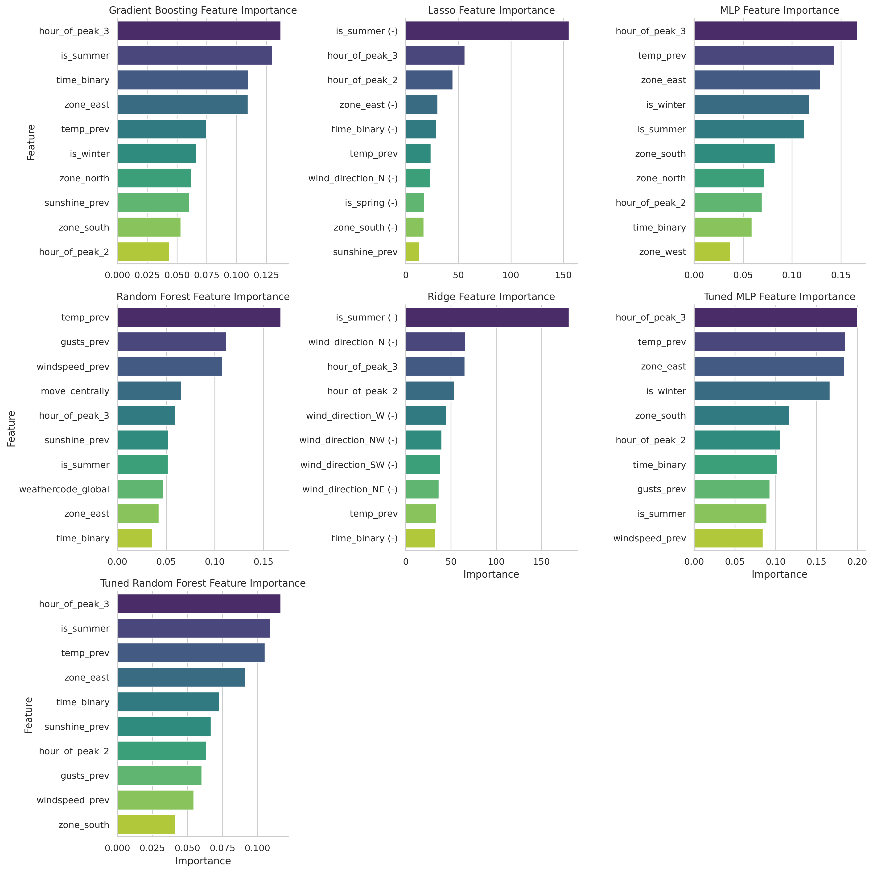Fig. 9. Top 10 Coefficient and Feature Importances by Model

Relationships between coefficient effects and feature importance weightings are explored in Table V, below.

In Table V, we can see that both linear and ensemble models agree on the
importance of seasonality, positional commuting hour, time of day, and the temperature of the previous hour in predicting traffic count. However, these models only align on one of the four origin/destination zones, and diverge in their weightings of wind-related variables (direction, gusts, and speed), sunshine, and weather intensity in predicting traffic count.

TABLE V
TOP 10 COEFFICIENT AND FEATURE IMPORTANCES BY MODEL EFFECT/INFLUENCE
 | Feature | Linear Model Coefficient Effect | Ensemble Model Influence
season, is_ | spring | slight reduction
season, is_ | summer | strong reduction | strong
season, is_ | winter |  | strong
wind_direction_ | N | moderate reduction
wind_direction_ | NE | slight reduction
wind_direction_ | NW | slight reduction
wind_direction_ | SW | slight reduction
wind_direction_ | W | slight reduction
zone_ | east |  | strong
zone_ | north |  | moderate
zone_ | south | moderate reduction | moderate
zone_ | west |  | weak
hour_of_peak | _2 | strong increase | moderate
hour_of_peak | _3 | strong increase | strong
time_binary | AM | slight reduction | moderate
move_centrally | in |  | moderate
weather | gusts |  | moderate
weather | intensity |  | weak
weather | sun | slight increase
weather | temp | moderate increase | strong
weather | wind speed |  | moderate
Note: For binary features, Table V only shows coefficients/feature imporances relative to the masked variables

Outcomes
The performance metrics of all seven models do not promote any of these modelling approaches in assessing the predictive strength of this set of features. RandomForest with HalvingRandomCV hyper-parameter tuning performed best with low variance attributions (28%), and relatively high average prediction error (~127 vehicles).
The most valuable findings from this project relate to apparent confirmation that features found to have greater effect or influence based on linear coefficients or ensemble methods, respectively, reflect patterns identified during EDA. These include the effects of time of day, positional commuting hour, season, wind direction (generally south).

Implementation
Considerations for implementing this solution in Production include: creating a more repeatable pipeline for data pre-processing (for example, including automatic directionality labelling). It would also be beneficial to confirm a source for continuous local traffic data counts which preferably covers an entire year.

Data answer
This modelling approach would have benefitted from the inclusion of more of the available traffic data (a greater selection of hours and dates), and the inclusion of polynomial features to highlight the interactions seen during EDA.
The selected models performed poorly at predicting commuter traffic counts while highlighting consistent and informative feature importances and coefficient effects.

Business answer
It is our opinion that the business question has not been satisfied by this data analysis, but that further exploration is likely to yield better results. This is informed by the patterns observed between EDA and the features emphasized by both Linear and Ensemble models.

Response to stakeholders
This project space is promising. It may be possible for these predictive models to achieve better results using more of the available traffic data. We would further recommend investigating polynomial features during further enquiry into the effects of weather on traffic patterns.

End-to-end solution
Deployment of the full data cleaning, feature engineering, pre-processing, and modelling pipeline depends on mechanisms for acquiring and/or ingesting, storing, and manipulating datasets of at least 810,000 rows (estimated size of combined traffic-weather dataset for 365 days). Modelling approaches should have processing capacity capable of handling these data volumes: On a single CPU processor, we estimate the same models would have a run-time of up to 2.5 days, assuming no major bottlenecks.

References

Notebooks:
RAM_Capstone - Wellington traffic vs weather 2025Nov v2.ipynb
- Data importing
- Data cleaning
- EDA
- Feature Engineering

RAM_Capstone – Wellington traffic vs weather Data Modelling 2025Nov.ipynb
- Data modelling

RAM_Capstone Project Presentation_2025Nov.pptx
- Presentation

Pip installs required
!apt-get install -y openjdk-11-jdk-headless
!pip install pyspark
!pip install geopy shapely

Libraries used
# API tools
import requests
import json

# Excel tools
import openpyxl as xl

# Basic utilities
import pandas as pd
import numpy as np

# Visualisations
import matplotlib.pyplot as plt
import seaborn as sns

from pyproj import transformer, Transformer

from pyspark.sql import SparkSession, DataFrame
from pyspark.sql import functions as F
from pyspark.sql.functions import udf, rank

from pyspark.sql.types import StructType, StructField, StringType, LongType, DoubleType, IntegerType, DateType
from pyspark.sql.window import Window

# Mapping tools
import folium
from geopy.distance import geodesic
from shapely.geometry import Polygon, Point, MultiPoint

# Core modelling
from sklearn.linear_model import Ridge
from sklearn.linear_model import Lasso
from sklearn.ensemble import GradientBoostingRegressor
from sklearn.ensemble import RandomForestRegressor
from sklearn.neural_network import MLPRegressor

# Pipeline & preprocessing
from sklearn.base import BaseEstimator, TransformerMixin
from sklearn.pipeline import Pipeline
from sklearn.compose import ColumnTransformer
from sklearn.preprocessing import StandardScaler, OneHotEncoder

# Model evaluation
from sklearn.model_selection import train_test_split, TimeSeriesSplit, cross_val_score, KFold, RandomizedSearchCV

from sklearn.experimental import enable_halving_search_cv
from sklearn.model_selection import HalvingRandomSearchCV
from sklearn.model_selection import HalvingGridSearchCV

from sklearn.metrics import mean_squared_error, mean_absolute_error, r2_score

# Feature selection
from sklearn.feature_selection import mutual_info_regression
from sklearn.inspection import permutation_importance

Datasets
Traffic count sites:
WCC_2024_selections v2.xlsx', sheet_name="WCC_sites_2024"
WCC_2024_selections_no_global_id.xlsx', sheet_name="WCC_sites_2024_no_global_id"
Traffic counts by site, quarter-hour, date, directionality
WCC_2024_selections v2.xlsx', sheet_name="WCC_tube_count_2024"
WCC_2024_selections_no_global_id.xlsx', sheet_name="WCC_tube_count_2024_no_global"

Weather data:
Example API call
# Average (representative centroid) coordinates for zone "south"
url_south = (
"https://archive-api.open-meteo.com/v1/archive?"
"latitude=-41.3238&longitude=174.7750"
"&start_date=2024-01-01&end_date=2024-12-31"
"&hourly=temperature_2m,rain,windspeed_10m,windgusts_10m,weathercode,winddirection_10m,sunshine_duration"
"&temperature_unit=celsius"
"&windspeed_unit=kmh"
"&windgusts_units=kmh"
"&precipitation_unit=mm"
"&timezone=Pacific/Auckland"
)
response_south = requests.get(url_south)
print(response_south.status_code)

Cover Page image:
[Fig 0] Wellington City Council, “Transport Procurement Strategy”. 2023-2026. [Online]. Available: https://wellington.govt.nz/-/media/your-council/about-the-council/procurement/files/transport-procurement-strategy.pdf?la=en&hash=E6D1D6A1A660C483AAF3F8DE309672B682E2CDF4

[1] New Zealand Transport Agency – Waka Kotahi, “Weather-activated speed sign trial set to start on Kaimai Range”, Media release, 2015. [Online]. Available:
https://nzta.govt.nz/media-releases/weather-activated-speed-sign-trial-set-to-start-on-kaimai-range

[2] reddit.com, r/Wellington. 28/02/2024. Thread: “Traffic be crazy”. User: CptnSpandex. [Online]. Available:
https://www.reddit.com/r/Wellington/comments/1b1vgdf/traffic_be_crazy/

[3] Wellington Regional Leadership Committee, “Metlink Public Transport Network overview”, Appendix 5.1, 2025. [Online]. Available: https://wrlc.org.nz/assets/Documents/Documents/2025/09/Appendix-5.1-Metlink-Public-Transport-Network-overview.pdf

[4] Greater Wellingon, “Bus stop infrastructure”, 2014. [Online]. Available: https://www.gw.govt.nz/assets/Documents/2014/11/2014.549.pdf

[5] Wellington City Council, “Vehicle counts”, Roads – Working on the road, 2025. [Online]. Available: https://wellington.govt.nz/parking-roads-and-transport/roads/working-on-the-road/vehicle-counts

Traffic count data source
[6] Wellington Transport Analytics, “Traffic Count Dashboards”, Downloads. [Online]. Available: https://wellingtontransportanalytics.co.nz/traffic-count-dashboard

Weather data source
[7] open-meteo.com, Historical weather API, [Online]. Available: https://open-meteo.com/en/docs/historical-weather-api

World Meteorological Organisation, Weather Codes
[8] World Meteorological Organisation, “WMO-CODE”, [Online]. Available:
https://www.nodc.noaa.gov/archive/arc0021/0002199/1.1/data/0-data/HTML/WMO-CODE/WMO4677.HTM

Radio NZ, “Weather watches and warning: what they means and when they’re triggered”, article, [Online]. Available:
https://www.rnz.co.nz/news/national/513904/weather-watches-and-warnings-what-they-mean-and-when-they-re-triggered

[9] Ministry of Education, “Term dates and holidays”, [Online]. Available: https://www.education.govt.nz/term-dates-and-holidays#term-2-10-weeks-2

[10] Geographic Information Services - Wellington City Council, “Local Maps Viewer”. [Online]. Available: https://gis.wcc.govt.nz/LocalMapsViewer/?map=2cb452a0159a439ea10afc03017c19ec

[11] National Institute of Water and Atmospheric Research, “Wellington Climate WEB.pdf”. [Online]. Available: https://niwa.co.nz/sites/default/files/Wellington_Climate_WEB.pdf

[12] Metservice, “5 years on from the 'big snow' of August 2011”, Blog, 15/08/2018.
[Online]. Available: https://blog.metservice.com/2011-big-snow-5-years-on

